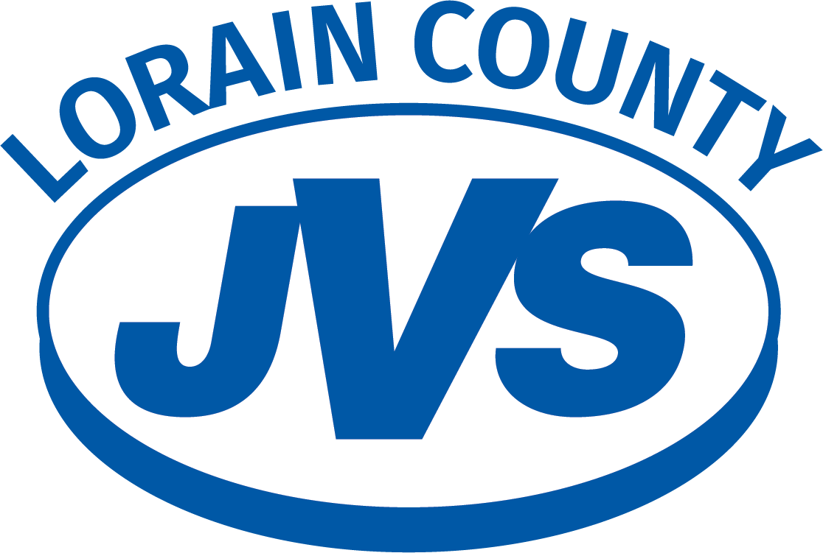

Communication and Procedures for Servicing Students with Disabilities

2023-2024 School Year
Table of Contents
About the Lorain County JVS 3
Mission 3
Vision 3
Core Beliefs 3
Enrollment 4
Recruitment Process 4
Application Procedures 6
Selection Process-11th Grade 6
Selection Process-10th Grade 7
Selection Process-9th Grade 8
Program Acceptance 8
Enrollment and Document Transfer Summary 9
Special Education Services 10
Transition of Special Education Information 10
Special Education meetings 10
At-Risk Students 10
Exam Accommodations 11
Contact Information 12

About the Lorain County JVS
Founded in 1971, the Lorain County JVS offers accredited career-technical education for high school students in grades 9-12 and adult learners. Through our programs, our students gain the skills, knowledge, and training needed to be a success in their careers. Located on a 100-acre campus in Oberlin, Ohio, LCJVS is one of the largest career tech schools in the state. We serve high school students from 13 school districts:
- Amherst
- Avon
- Avon Lake
- Clearview
- Columbia
- Elyria
- Firelands
- Keystone
- Midview
- North Ridgeville
- Oberlin
- Sheffield-Sheffield Lake
- Wellington

Our Adult Career Center serves adult learners from surrounding communities.

Mission
We create opportunities for students to achieve success in their careers.

Vision
By 2023, the Lorain County JVS will be the model Career and Technical Education Center in the state of Ohio.

Core Beliefs
- We believe in the engagement of all stakeholders.
- We believe in providing pathways of success for all students.
- We believe in a rigorous and relevant curriculum that increases achievement.
- We believe in recruiting, developing, and retaining highly qualified employees.
- We believe we are all responsible for the success of students.
- We believe in developing and sustaining partnerships.

Enrollment

Recruitment Process
- County high school counselors meet quarterly at LCJVS in September, November, January, and May.

- In the fall, LCJVS collects addresses for all enrolled 7-12 grade students in our 13 associate school districts.

- In September, 8th-grade counselors from the associate schools meet at LCJVS. This meeting aims to provide the 8th-grade counselors an update on the 9th-grade program, issues, events, and policies that impact their students. At this meeting, counselors are provided with individual program information sheets for 9th grade, dates to remember, and are encouraged to schedule a tour of the building for their 8th graders.

- The LCJVS high school counselors present to sophomores at associate high schools in October and November. They provide information on career tech education and the programs offered at LCJVS, and they invite the students to attend the Sophomore Career Days field trip in November.

- The online application for the new school year is available by November 1.

- LCJVS sends postcards to 8th-9th-10th grade students promoting Open House and applications in September, October, November, December, and January.

- Sophomore Career Days are held annually in November. This field trip is open to all sophomores at associate districts and showcases the programs that LCJVS offers. Students select two programs to visit.

- Open House is in November. This event targets parents and potential students in 8-10th grade and adult learners.

- 8th graders are encouraged to attend tours of LCJVS with their classes beginning in October.

- The applications timeline is presented to county counselors with a due date in mid-February. Applications are processed after this date but will continue to be accepted for open positions in programs until September 1.

- For additional experience, students can ask to shadow up to two other labs during the school day with permission from their district to ride the bus to LCJVS.

- Postcards reminding students to apply in early February are sent to all 8th-9th-10th graders.

- Applications are collected and sorted by program interest in mid-February.

- Current LCJVS 9th and 10th graders complete their program and course requests to remain at JVS by mid-February.

- Acceptance letters for new students and in-house students are mailed in April. Students that were not accepted in the first round are placed on further review for grade/credit deficiencies.

- Meetings are set at the associate school in April-May for students placed on further review or a waitlist.

Application Procedures
- All interested students must apply online at https://lcjvs.esvportal.com/applicationslogin.aspx.

- Once a student applies, the parent/guardian, school counselor, Recruitment/Enrollment Coordinator, and recruitment administrative assistant receive an email of submission.

- School counselors supply needed transcripts or report cards.

Each application is grouped by program and considered based on grade level requirements.

For 11th grade:
- On-track for graduation (2 English, 2 math, 2 science, 2 social studies, .5 each Health/P.E. )*
- Special consideration for Public Safety requirements
For 10th grade:
- On-track for graduation (1 English, 1 math, 1 science, 1 social studies, .5 credit of Health or P.E.)*
For 9th grade:
- On-track for graduation – matriculated from 8th-9th grade.
  - Students who have applied to open programs and have credit deficiencies will schedule a meeting to discuss options and pathways to graduation. Public safety candidates have specific GPA, physical, or test score requirements.
- Completed application from the associate school
- Students are grouped for consideration by their interest choices. There are 50 spots each in five different areas.

Selection Process-11th Grade

- Students at LCJVS are considered for CTE programs first if credit requirements are met, and they remain in good standing with the LCJVS.

- Once all components (transcript, report card, credit checks) of the external applicant’s application are submitted and reviewed, they are sorted by their requested program choice.

- 25 is the maximum number of students for most programs. Exceptions include 24 in each Allied Health Sciences Lab and 15 in each lab for Hospitality Services, Maintenance Services, and Job Training Program.

- Applicants that meet requirements are accepted, pending space in their chosen program.

- Applicants with questions or minor deficiencies (i.e., not attending a member school, attendance issues…) will receive conditional acceptance with requirements listed that should be completed to ensure success and on-time graduation while in the program.

- Applicants placed on “Further Review” because of credit deficiencies will have a meeting with the Recruitment/Enrollment coordinator.

- Applicants who apply for an incorrect program (i.e., 8th grader applying for 11th grade) are marked as “Not Accepted” and encouraged to apply again for the correct program.

- If the program has reached the maximum, students are encouraged to:

- Remain on the waitlist for that program
- Apply for a new program that may have room
- Meet with the Recruitment/Enrollment coordinator during “further review” interviews to discuss options.

Selection Process-10th Grade
- Students at LCJVS are considered for 10th-grade spots first if credit requirements are met, and they remain in good standing with the LCJVS.

- Once all components (transcript, report card, credit checks) of an external applicant’s application are submitted and reviewed, they are sorted by their requested program choice.

- Applicants are considered for open spaces in each program lab. In 2022, we have ten labs of 25 available. 25 is the maximum number in most labs. They are sorted into five interest-categories with 50 spots in each category: Construction, Mechanical, Service/Culinary, Graphics/Computers, and Health Professions.

- Applicants meeting requirements with room in their program choice will be accepted.

- Applicants with questions or minor deficiencies (i.e., not attending a member school, attendance issues…) will receive conditional acceptance with requirements listed that should be completed to ensure success in the program and on-time graduation while in the program.

- Applicants placed on “Further Review” because of credit deficiencies will have a meeting with the Recruitment/Enrollment coordinator.

- Applicants who apply for an incorrect program (i.e., 11th grader applying for 10th grade) will be “Not Accepted” and encouraged to apply for the correct program.

- If the program has reached the maximum, students are encouraged to:

- Remain on the waitlist for that program
- Meet with the Recruitment/Enrollment coordinator during “further review” interviews to discuss options.

Selection Process-9th Grade
- Once all components (transcript, report card, credit checks) for 8th-grade applications are submitted and reviewed, they are sorted by their requested program choice and sorted into five interest categories, with 50 spots in each category: Construction, Mechanical, Service/Culinary, Graphics/Computers, and Health Professions. In 2022, we have ten labs of 25 available.

- Applicants meeting requirements from associate member districts with room in their interest choice are accepted. Students not currently enrolled in the member districts are considered for spaces in their interest choice.

- Applicants with questions or minor deficiencies (i.e., not attending a member school, attendance issues…) will receive conditional acceptance with requirements listed that should be completed to ensure success in the program and on-time graduation while in the program.

- Applicants who apply for an incorrect program (i.e., 8th grader applying for 11th grade) are marked as “Not Accepted” and encouraged to apply again for the correct program.

- If the program has reached the maximum, students are encouraged to:

- Remain on the waitlist for that program
- Apply for a new interest choice that may have room

Program Acceptance
- All applicants will receive a letter explaining their status in early spring. The status includes:
- Accepted – applicant is in their program choice. The student will reply to LCJVS by logging in to enroll. Login information is included in the letter and forwarded to the associate school counselor.
- Accepted with Conditions— applicant was placed in their program choice with conditions listed for success in the program and to graduate on time. The student will reply to LCJVS by logging in to enroll. Login information is included in the letter and forwarded to the associate school counselor.
- Waitlisted – applicant was placed on a waitlist for the program and will remain there until/if a spot becomes available. The applicant can consider another program and reapply.
- Further review– students placed on “Further Review” because of credit deficiencies will have a meeting with the Recruitment/Enrollment coordinator at their school.
- Not Accepted – applicants applying to programs that are not on track for graduation are notified of specific credit deficiencies.

- Directions to log in to the LCJVS forms site and complete their enrollment for fall are included in the letter. The letter indicates that students have a trial period to return to their associate school up to the second Tuesday of the year.

- An informational orientation event is hosted at LCJVS in the summer, ten days before the first day. One day is for new incoming students, and one day is for returning students in all grades.

- The LCJVS Recruitment/Enrollment Coordinator and LCJVS Director of Special Education Program communicate acceptance information to LCJVS associate districts’ counselors and special education directors.

Enrollment and Document Transfer Summary
Month | Description
September | 1st of 4 high school counselors’ meetings  8th-grade counselor meeting
Begin in October  November | 8th graders tour LCJVS  2nd High School Counselor meeting
October November  September-January | Sophomore presentations at Associate schools-invite to Career Days  Postcards sent to all 8th-9th-10th graders
November | Sophomores visit LCJVS Campus -Career Days
November | Open House - Sunday
January | 3rd High School Counselor meeting
February | Postcards sent to all 8th-9th-10th to encourage applications
April | Status Letters sent
April -May  April -August | Recruitment/Enrollment Coordinator Further Review meetings at Associate schools  Special Ed. Director collects ETR/IEP on accepted students and meets at associate schools
May | 4th High School Counselor meeting
June-August | Waitlist and Further review applications reconsidered in open programs

Special Education Services
Each Intervention Specialist is assigned 24 to their caseload as a maximum number of students.
A master list of all students that includes, but is not limited to, IEP meeting dates and case managers is emailed to all District Directors weekly through September. Updates are emailed as needed throughout the year.
At the beginning of each year, the Intervention Specialist reviews the IEP and schedule to ensure the student is in the correct Least Restrictive Placement (LRE) placement. They monitor progress quarterly to ensure accommodations are utilized, and that progress is made on annual goals. All teachers receive a copy of the ETR and IEP for each student they teach on their roster by the first day of school. Intervention Specialists are responsible for communicating with the parent/guardian throughout the year.

Transition of Special Education Information
- In early Spring, School Counselors and Special Education Directors are informed of who has applied and their status: accepted, further review, or waitlist.

- LCJVS Supervisor sends out monthly block IEP meeting invites for the next school year each June to get it on the Director's calendar.

- In April and May, the Special Education Supervisor goes to each Associate school to meet with incoming students and their parents/guardians. Once the student has formally accepted coming to Lorain County JVS, all special education documents are transferred to the Lorain County JVS through Samegoal. All 13 districts use the Samegoal IEP software program. When a student transfers from a district that does not have Samegoal, a hard copy is provided to the Lorain County JVS.

- In August, all Directors get a master list of all their students attending the Lorain County JVS. This list is sent weekly to ensure no student is missed.

Special Education meetings
1. Lorain County JVS schedules all IEP and ETR meetings at Lorain County JVS. The Directors and Transition Coordinators are invited to all EIP and ETR meetings.
2. When needed, the Lorain County JVS will hold periodic team meetings and invite the associate school director.
3. The Director is invited to all Manifestation Determination meetings.

At-Risk Students
- Lorain County JVS's Supervisor keeps Associate School Directors informed of students at risk of failing.

- Lorain County JVS's School Counselors communicate with Associate School Counselors to ensure transcripts and graduation requirements are met.
- Lorain County JVS has its attendance officer working with the Assistant Principal for truancy issues. The Supervisor keeps the Directors up to date on students who are not attending.

Exam Accommodations
- Associate Schools are responsible for applying for accommodations for the ACT/SAT. Lorain County JVS Lab Instructors will apply for accommodations for Industry Exams as needed.
Name | Position | Email | Phone (440) 774-1051
Career Services
Mathias Hauck | Career Services Specialist | mhauck@lcjvs.net | Ext. 22232
Counseling
Joanne Gleason | Counselor | jgleason@lcjvs.net | Ext. 22284
Shannon Meadows | Counselor | Smeadows@lcjvs.net | Ext. 22269
Chris Wilde | Counselor | cwilde@lcjvs.net | Ext. 22267
Enrollment/Recruitment
David Keller | Recruitment/Enrollment Coordinator | dkeller@lcjvs.net | Ext. 22323
Special Education
Denise Scarpucci | Supervisor | dscarpucci@lcjvs.net | Ext. 22262
Dawn Balog | Intervention Specialist | dbalog@lcjvs.net | Ext. 22236
Katie Berardi | Instructor and Intervention Specialist | kberardi@lcjvs.net | Ext. 22446
Lauren Canada | Intervention Specialist | lcanada@lcjvs.net | Ext. 22306
Ashley Czatt | Intervention Specialist | aczatt@lcjvs.net | Ext. 22201
Steve Eby | Intervention Specialist | seby@lcjvs.net | Ext. 22361
Beth Gillam | Intervention Specialist | bgillam@lcjvs.net | Ext. 22209
Andrea King | Intervention Specialist | aking@lcjvs.net | Ext. 22444
Sue Kiss | Intervention Specialist | skiss@lcjvs.net | Ext. 22455
Holly Koepp | Intervention Specialist | hkoepp@lcjvs.net | Ext. 22439
Loren McManamon | Intervention Specialist | lmcmanamon@lcjvs.net | Ext. 22317
Pam Pearson | Intervention Specialist | ppearson@lcjvs.net | Ext. 22374
Rachelle Potter | Intervention Specialist | rpotter@lcjvs.net | Ext. 22316
William Ready | Instructor and Intervention Specialist | wready@lcjvs.net | Ext. 22225
Molly Shapiro | Intervention Specialist | mshapiro@lcjvs.net | Ext. 22385
Elizabeth Vamosperci | Intervention Specialist | evamosperci@lcjvs.net | Ext. 22343
Lisa Zane | Intervention Specialist | lzane@lcjvs.net | Ext. 22488

Contact Information

